Name:________________________________________ Date:____________

**Practical activity: Modelling the effect of vaccinations**

**Learning Intentions:**1. Using a model, explain how the vaccination rate affects the spread of disease

2. Evaluate how well the activity models a real-life outbreak

An **outbreak** is a sudden increase in cases of an infectious disease in a particular place. An outbreak occurs when a disease begins to spread from person to person. How this happens depends on the disease. For example, the measles virus spreads in droplets when an infected person coughs or sneezes.

The percentage of people in a population who are vaccinated is called the **vaccination rate**. For example, a vaccination rate of 95% for the measles vaccine can stop the disease from spreading. This protects the other 5% of the population who are not vaccinated.

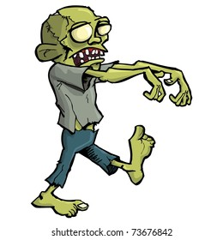

**Question 1:**

**Question 2:**

**Question 4 – KEY QUESTION**

Use your graph to **explain**how the number of infections changed as the vaccination rate increased.

___________________________________________________________________________  
  
___________________________________________________________________________  
  
___________________________________________________________________________  
  
___________________________________________________________________________  
  
___________________________________________________________________________  
  
___________________________________________________________________________

**Question 5:**

This activity is a model that represents a real-life outbreak of disease. Every model has advantages and limitations.

**Evaluate** this activity as a model by identifying its advantages and limitations.

*****Note: You don't need to fill in every row of the table.*

**Question 6:**

**Write**a short concluding paragraph that:

* responds to your aim, and
* restates your findings about how vaccinations affect the spread of disease.

___________________________________________________________________________  
  
___________________________________________________________________________  
  
___________________________________________________________________________  
  
___________________________________________________________________________  
  
___________________________________________________________________________  
  
___________________________________________________________________________

**Notes Page**

___________________________________________________________________________  
  
___________________________________________________________________________  
  
___________________________________________________________________________  
  
___________________________________________________________________________  
  
___________________________________________________________________________  
  
___________________________________________________________________________  
  
___________________________________________________________________________  
  
___________________________________________________________________________  
  
___________________________________________________________________________  
  
___________________________________________________________________________  
  
___________________________________________________________________________  
  
___________________________________________________________________________  
  
___________________________________________________________________________  
  
___________________________________________________________________________  
  
___________________________________________________________________________  
  
___________________________________________________________________________  
  
___________________________________________________________________________  
  
___________________________________________________________________________